Day in the Life of the Hudson River 10/13/22
Haverstraw Bay Park, Haverstraw, NY
RIVER MILE: 38
Salt Front: ~ RM76
Millie Mendelson & Adam Yuan - Albertus Magnus High School
NYS SCA & Rockland County Parks
(Honor’s Biology, 9th grade & Environmental Pollution, 11th & 12th grade) –
45 students & 4 adults
Latitude 41.212805 N & Longitude – 73.963990 W
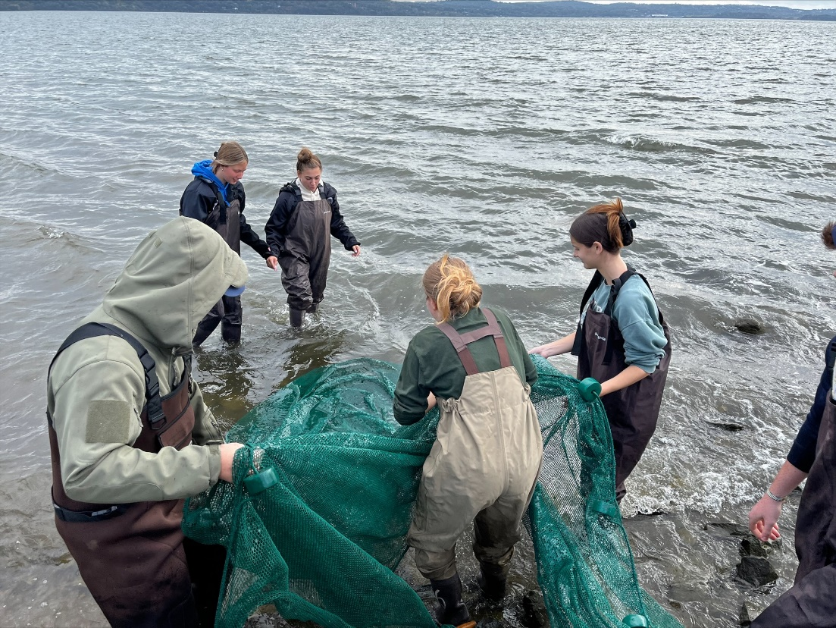 | 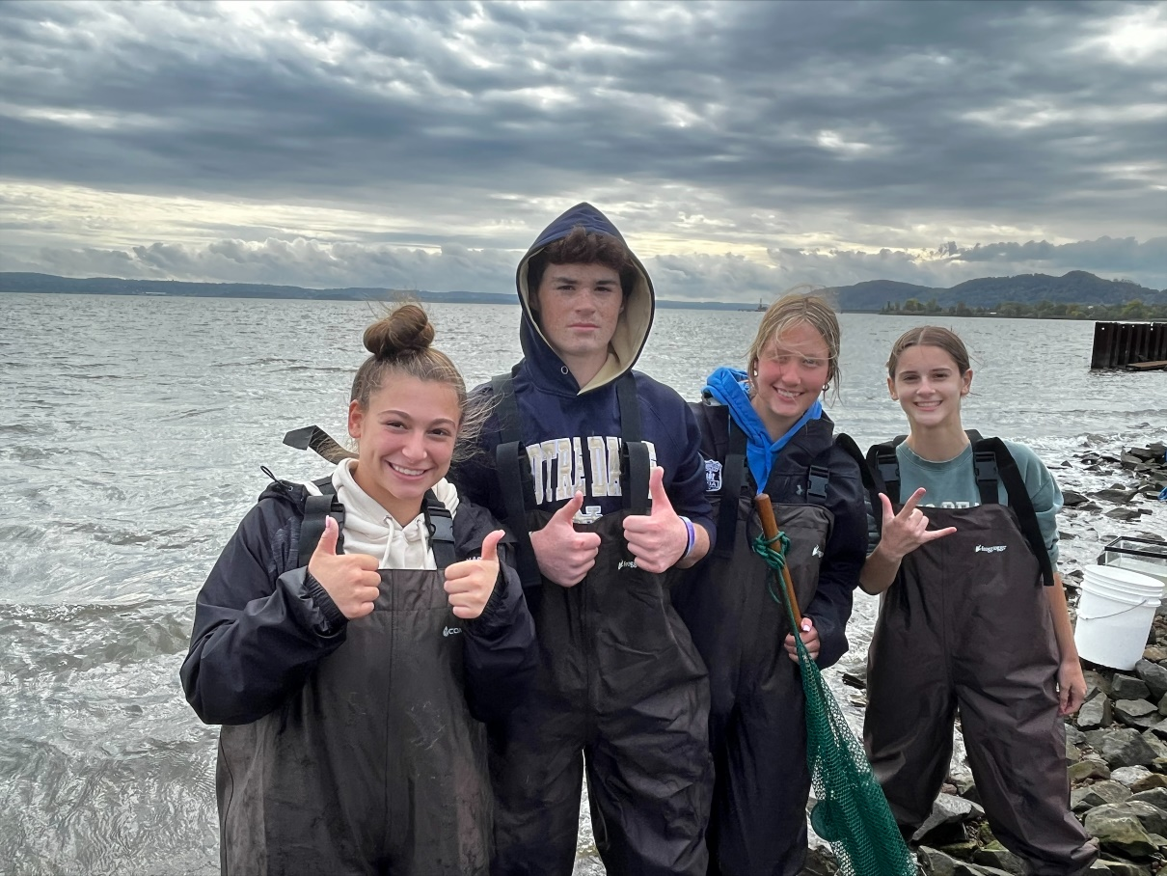 | 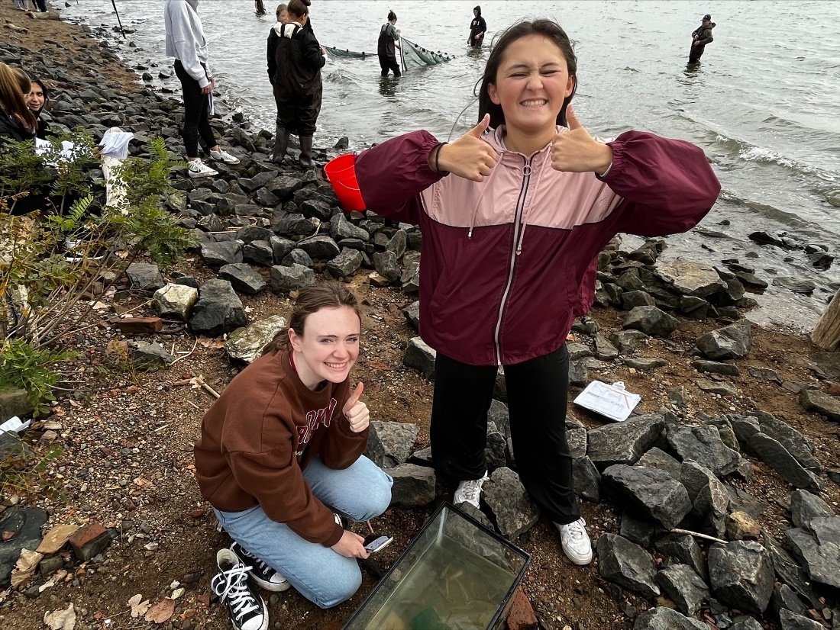

Location: Haverstraw Bay Park, Haverstraw, NY
Area: North Shore of Haverstraw Bay Park
Surrounding Land Use: 65% Urban/Residential, 30% Industrial/Commercial, 5% Beach
Sampling Site: Pier, forested, grassy, beach, altered banks, parking lot, covered in vegetation, RipRap, concrete bulkhead, marshy
Shoreline: 40% Sandy, 20% Muddy, 40% Rocky
Water: Choppy
Plants in area: No plants in the water
River Bottom: muddy, sandy, and rocky
*NR = Not read/recorded
ITEM |  | Time |  | Reading |  |  |  | Comments
Physical
Air Temperature |  | 10:09 AM  10:29 AM  11:05 AM |  | 17.8º C  18.3 º C  17.8 º C |  |  | 64°F  65°F  64°F
Wind Speed: |  | 11:06 AM |  | Anemometer  12 mph |  |  | Beaufort  3 | Direction  S/SE
Weather today |  | 10:57 AM |  | > 75% cloud cover |  |  | Drizzle
Weather the past 3 days: |  | Sunny high 60's; seasonable
Tides- Tide Stick |  | Time |  | Rising, Falling, Unchanged |  |  | Water Height (cm)
 |  | 9:50 AM  10:14 AM  10:22 AM  10:32 AM-  10:57 AM |  | Rising  Rising  Rising  Rising  Rising |  |  | 55 cm  65 cm  70 cm  75cm  85cm
Current- |  | Time |  | Cm/sec |  | Knots | North/South | Ebb/Flood/Still
 |  | 9:55 AM  10:04 AM  10:08 AM  10:11 AM  10:28  10:32 AM  10:46  11:02 AM |  | 53  203  33  21  64  104  43  50 |  | NR | NR | Flood  Flood  Flood  Flood  Flood  Flood  Flood  Flood
Water Temperature- |  | 9:52 AM  10:18 AM  10:36 AM  10:45 AM |  | 17.15 º C  17 º C  17.4 º C  17.4° C |  |  | 62.87 º F  62.6 º F  63.3º F  63.3º F | Averages
Turbidity- Long sight tube (120 cm)  Secchi Disk (cm) |  | 10:30 AM 10:54 AM  11:53 AM  12:03 PM  10:04 AM 10:37 AM |  | 48.25 cm  27.25 cm  22.67 cm  27.56 cm  58 cm  44.33 cm |  |  | Each reading average of 3  Each Reading Average of 3
Chemical
Salinity- HR Quantabs |  | 10:11 AM  11:02 AM  12:10 PM |  | 7.8 quantab units  7.9 quantab units  7.8 quantab units |  |  | 3216  3365  3216 | 5,810 ppm  6079.ppm  5810 ppm
Standardized Salinity – HR Quantab |  | 10:36 AM |  | 7.8 quantab units |  |  | 3216 | 5,810 ppm
DO – Hach Drop Count Kit |  | Time |  | Temp |  |  | ppm DO | % saturation
 |  | 9:52 AM  19:18 AM  10:45 AM |  | 17.2° C  17.0° C  17.4° C |  |  | 10.5ppm  10ppm  8ppm | 105%  104%  85%
pH – Color Match Kit |  | 9:57 AM  10:30 AM  10:58 AM |  | 7.0/7.2/7.2  7.2  7.2/7.3 |  |  |  | Morning average 7.2
Nitrates- NR
Phosphates- NR
Alkalinity- NR
Biological
Fish – Seine |  | Number |  | Name |  |  | Length of longest | Length of smallest
9:50 AM- 12:15 PM |  | 182  9 |  | Atlantic Silverside  Striped Bass
Fish Totals |  | TOTAL: 191 |  | Diversity: 2
Macroinvertebrates |  | Number |  | Name |  |  | Length of longest | Length of smallest
Macroinvertebrate Totals |  | TOTAL: 0 |  | Diversity: 0
Sediment Core - NA, too rocky to core
Length | H2S smell |  | Oxid Top |  | Oil |  | Grain Size | Other Features
Boats-
 | Time |  | Name |  | Color |  | North/Southbound | Light/Loaded
Commercial | 9:57 AM  10:13AM  10:26AM  10:36AM 12:20PM |  | NR  Tug  NR  Cargo  NR |  | White  Black  NR  Grey  Red, Brown |  | Northbound  Southbound  Northbound  Southbound  Southbound | Light  Loaded  Loaded  Loaded  Loaded
Residential | 9:50 AM  10:50AM |  | Jetski  Speed Boat |  | Blue  White |  | Northbound  Northbound | N/A  N/A

